Web Application Development Project S2: Football Tracking Website

Yash Jagwani & Felix Morenc

Fontys 2020

Intro:

For this Web Application Development course, we decided to create a website with a Football theme as it was a concept that appealed to all group members. After further brainstorming, we settled on developing a sort of hub website for things related to the Premier League, where users can come to check on upcoming games, results and most importantly player stats such as goals and assists. While this isn’t a revolutionary concept, we felt it would be a useful website providing us a good platform to use everything we learn throughout the course. After deciding on our website concept we proceeded to create wireframes, seen in the next section.

Wireframes:

In our wireframes, we decided to focus on arguably the two most important viewports, mobile and desktop.

**Home Page**

*Desktop*

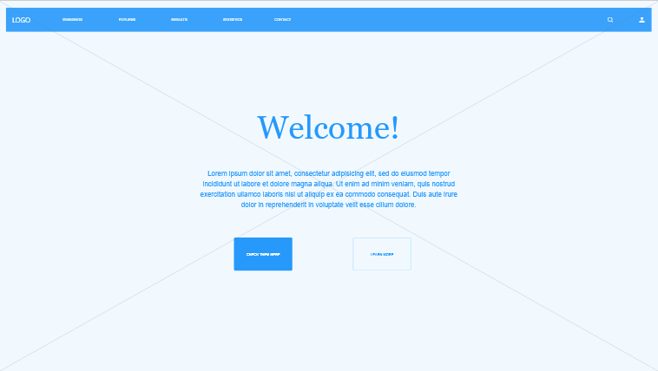

*Mobile*

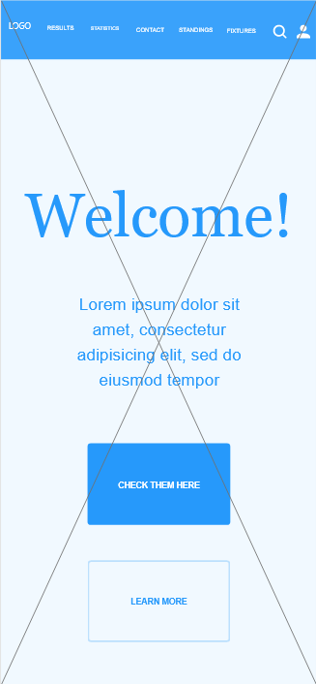

**Top Scorers Page**

*Desktop*

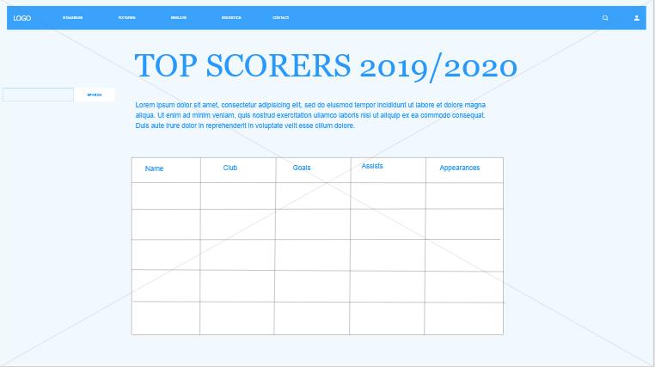

*Mobile*

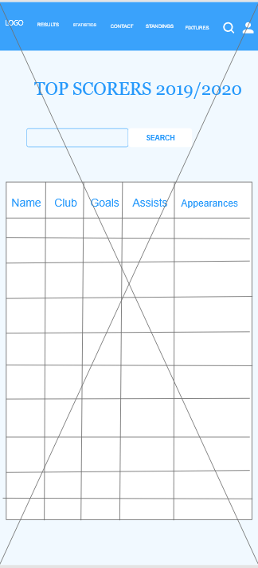

Link to website:

You can view our website on this link:

<http://i431015.hera.fhict.nl/>